Pelvic Fracture with intraperitoneal bladder rupture.
Stem: A 22 year-old is on a motorcycle group ride when he crashes his motorcycle on the highway. He is helmeted. He is thrown approximately 30 feet. The patient is found unconscious by emergency medical services (EMS).
He is hypotensive with systolic blood pressure in the 80s. He responds to a 1 L normal saline (NS) fluid bolus by EMS, and systolic blood pressure is now 100 mm Hg.
Upon arrival to the trauma bay, he is awake but confused. He is tachycardic with heart rate in the 140s. Systolic blood pressure is back in the 80s. He is given 2 units of uncrossmatched O positive blood. He is complaining of lower abdominal pain and significant bilateral hip pain.
What would you like to do now?
-ATLS (ABC DE) (Airway, b reathing, circulation, disability, exposure).
-Two wide bore 16-18 gauge IV cannulas.Obtain blood for labs (Type and screen / cross match, CBC, CMP, Coags, lactate).
- Secondary Survey:
-Pelvic ring instability:How? applying gentle pressure from the lateral aspect of each iliac wing with both hands.
-Lower extremity abnormal rotation.
Blood at uretheralmeatus.
DRE
-Chest and pelvic films.
-FAST.
The patient in the scenario undergoes a chest x-ray with no acute findings Pelvis x-ray shows:
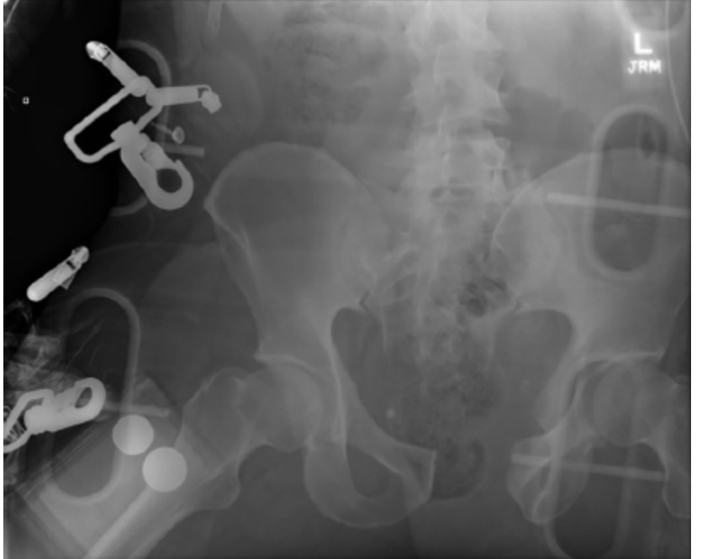
W idening of the pubic symphysis. There is diastasis of the right sacroiliac (SI) joint.
Now what?Pelvic binder
- The patient was resuscitated according to ATLS guidelines. He stabilized after transfusion of 2 units of blood in the trauma bay. A pelvic binder was placed. FAST was positive for fluid in the pelvis.
Now what? CT imaging.
- CT imaging.
  - A large volume of contrast-enhanced urine was identified within the peritoneum on delayed images.(To the examiner:consistent with urine extravasation and not contrast from pelvic vasculature)
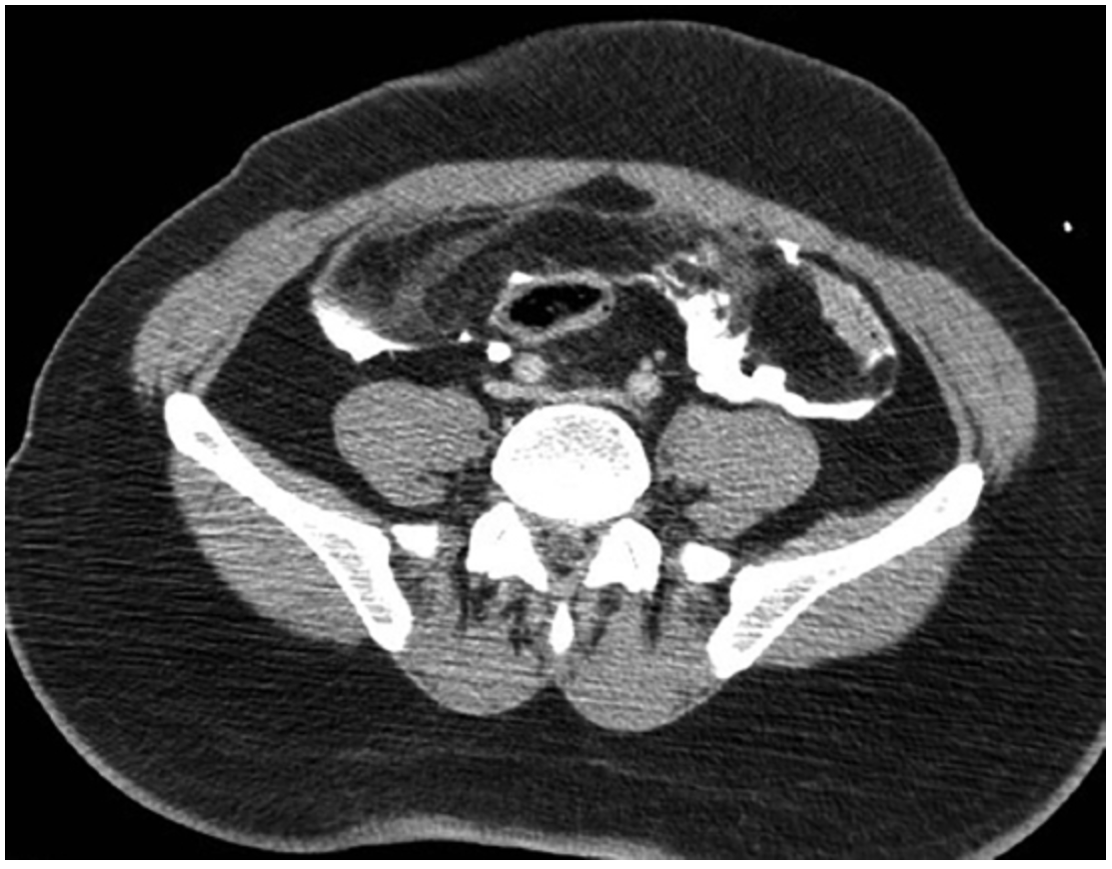
- An “open-book” pelvic fracture.You get 3-D reconstruction image.
- 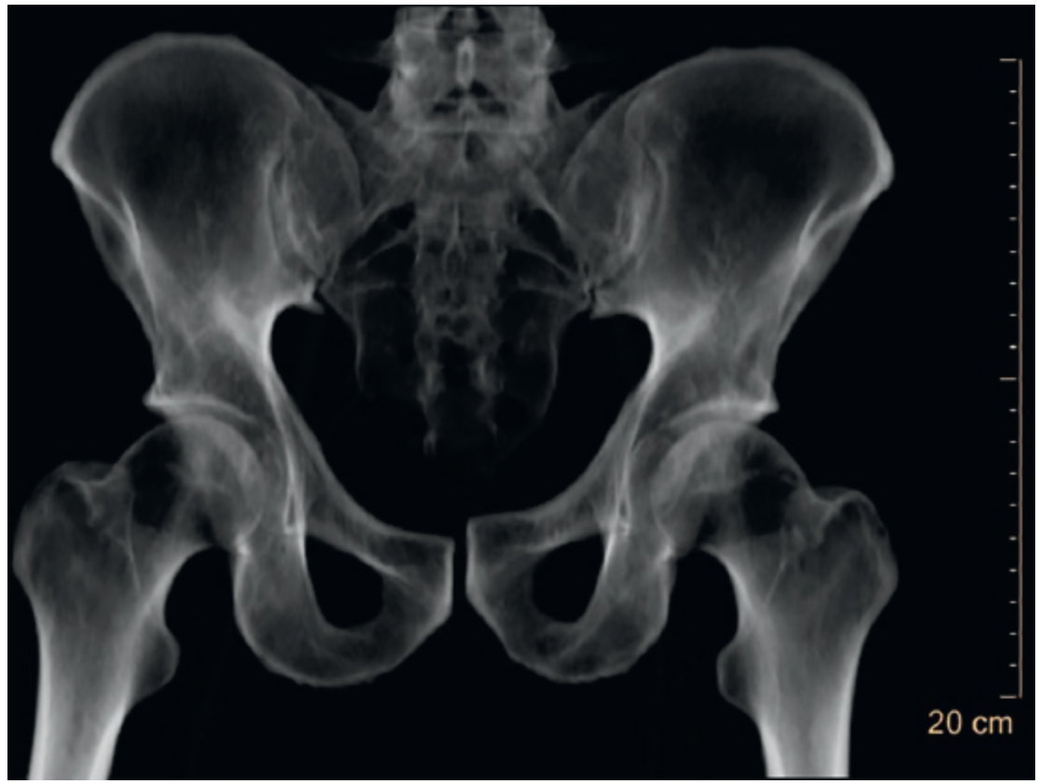

What is your diagnosis and what is your next step?
- Intraperitoneal bladder rupture and open book pelvic fracture.
- Ex. Lap: Limited incision as extending the incision below the semilunar line may lead to further hemorrhage by increasing anterior extension of a pelvic hematoma.
- Bladder repair.How?
  - Assess trigone and ureters.
  - Two layers.
  - Test repair by instilling 200 mL of normal saline into the bladder, clamp the foley and assess for leak.
  - Leave Foley.
- Ortho were involved and t he patient underwent open reduction and internal fixation of pelvic fracture with a plate and closed treatment of right SI joint diastasis.
Can you describe the classification of pelvic fractures?
- five categori e s:
  - lateral compression (grades I to III)
  - Anterior compression (grades I to III)
  - V ertical shear
  - C ombined mechanism
  - Acetabular fractures

Scenario:Same patient,CT showed contrast extravasation in the pelvis and the patient remained hemodynamically stable after blood transfusion. Then what?
Angioembolization
Scenario:Same patient, patient was hemodynamically, stabilized with blood transfusion CT showed contrast extravasation in the pelvis. After CT patint became again hypotensiv e. You proceeded to the OR for ex.lap. Describe?
  - Ex. Lap: Limited incision, stay above the semilunar line. (Extending the incision below the semilunar line may lead to further hemorrhage by increasing anterior extension of pelvic hematoma) Tightly packing the pelvis intraperitoneal.
  - Preperitonealpacking with separate lower incision.
  - Temporary abdominal closure.
  - Postoperatively, the patient may need to be managed with angiography and embolization if there is continued hemorrhage.
  - Once stabilized, the patient can be returned to the operating room for re-exploration. S tabilization of the pelvis fracture, either internal or external, may be considered in conjunction with orthopedics.

